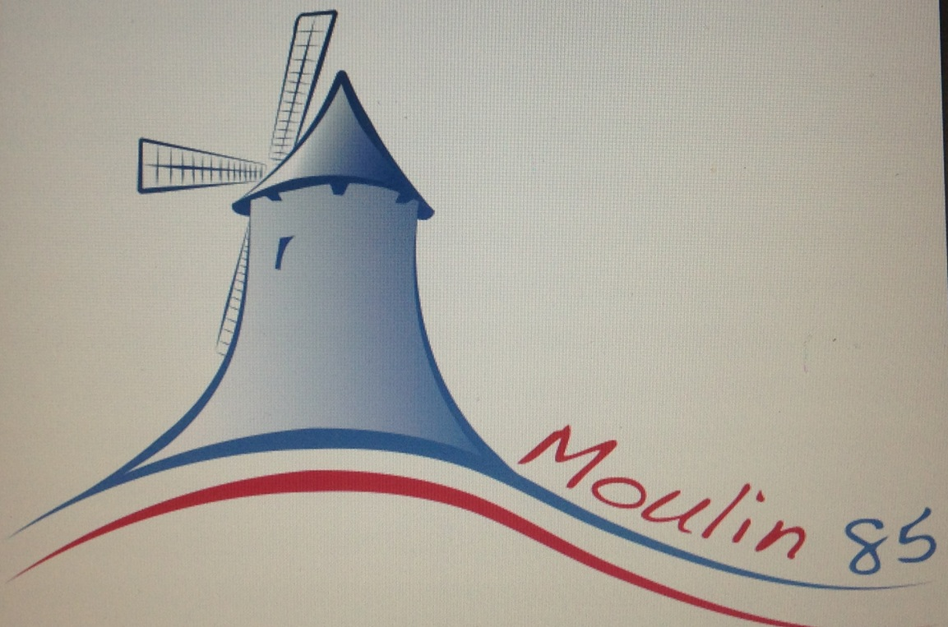
TERMS & CONDITIONS

The dwelling known as ‘The Moulin’ (“The Property”) is offered, for Holiday Rental subject to confirmation by Sally Herbert (“The Owner”) to the renter (“The Client”).

To reserve the property, the client should complete the Booking Form and return it, together with the non-refundable deposit of £100. Following receipt of the Booking Form and deposit, the Owner will send a confirmation letter. This constitutes formal acceptance of the booking.

Balance of the rental, together with the security deposit (see next clause) is payable, not less than 12 weeks before the start of the rental period, where applicable. If payment is not received by the due date, the Owner reserves the right to give notice, in writing that the reservation is cancelled. Reservations made within 12 weeks of the start of the rental period require payment at the time of booking.

Refundable security deposit of £100 is required in case of, for example, damage to the contents or property. However, the sum reserved by this clause shall not limit the client’s liability to the Owner. The Owner will account to the Client for the security deposit and refund any balance due within two weeks after the end of the rental period.

Subject to earlier clauses, in the event of a non-insurable cancellation, refunds of balance amounts paid will be made if the Owner is able to re-let the Property. Any expenses or loses incurred in doing so will be deducted from the refundable amount (booking element is not refundable).

The Client is strongly advised to arrange a comprehensive travel insurance policy (including cancellation cover) and have full cover for your party’s personal belongings, public liability etc., as these are not covered by the Owners insurance. It is recommended that all travellers apply for and carry an EHIC (European Health Insurance Card). This card replaced the E111. Apply on-line at www.ehic.org.uk/internet/home.do

The rental period shall commence at 14.00 (2 pm) on the first day and finish at 09.30 (am) on the last day. The Owner shall not be obliged to offer accommodation before the time starts and the Client shall not be entitled to remain in occupation after the time stated.

The maximum number of occupants at the Moulin is two.

The Client agrees to be a considerate tenant and to take good care of the Property and to leave it in a clean and tidy condition at the end of the rental period. The Owner reserves the right to make a retention from the security deposit to cover any damage or additional cleaning costs, if the Client leaves the property in an unacceptable condition.

The Client shall report to the Owner, without delay, any defect or breakdown in the equipment or appliances in the property or any of the facilities, so that arrangements can be made for repair or replacement as soon as possible.

The Owner shall not be liable to the Client for any temporary defect or stoppage in the supply of public services to the property nor in respect of any equipment, machinery or appliance in the property, garden or accommodation for any loss, damage or injury which may be, as a result of adverse weather conditions, riot, war, strikes or other matters beyond the Owners control.

The Owners liability to the Client will not exceed the amount paid to the Owner for the rental period.

The Client(s) agree that any comments made in the Visitors Book can be quoted, without full names on this and other lettings websites.

No pets are allowed at the premises under any circumstances (with the exception of Guide Dogs and Assistance Dogs).

FINALLY, YOU SHOULD NOTE THAT BECAUSE OF THE NATURE OF THE PROPERTY, THERE CAN BE TIMES WHEN STRONG WIND IS PRESENT…. REMEMBER, IT IS A WINDMILL!!!

